**Ideation Phase**

**Define the Problem Statements**

|  |  |
| --- | --- |
| Date | 28 June 2025 |
| Team ID | LTVIP2025TMID29793 |
| Project Name | Calculating Family Expenses using Service Now |
| Maximum Marks | 2 Marks |

**Customer Problem Statement:**

**Who is the customer?**

The primary customers are families or household units that need a structured, centralized, and user-friendly system to track and manage their daily and overall expenses.

**What is the problem?**

Families often struggle with:

* Disorganized and manual tracking of expenses across various categories.
* Difficulty linking daily expenses to overall household budgets.
* Limited visibility into spending patterns, leading to poor financial planning.
* Lack of automation in monitoring budgets, which can result in overspending without timely alerts.

**Why is this problem important to solve?**

Without an efficient expense tracking system, families may face:

* Financial uncertainty due to unmanaged spending.
* Missed opportunities for budgeting and saving.
* Increased time and effort spent on managing finances manually.
* Difficulty making informed financial decisions that support long-term well-being.

**How does the customer currently address this problem?**

Many families rely on manual methods such as spreadsheets, paper records, or basic mobile apps that are not linked, lack automation, and do not provide comprehensive reports or budget tracking features.

**What is the desired outcome?**

A centralized, automated, and scalable system that:

* Allows families to record, categorize, and link expenses easily.
* Provides real-time insights into spending patterns.
* Generates automated identifiers and reports for better tracking.
* Issues alerts when budgets are exceeded to prevent overspending.
* Simplifies the financial management process with a user-friendly interface.

**Empathy and Customer Viewpoint**

By focusing on these needs, the solution aims to empower families with tools that not only simplify expense tracking but also promote financial discipline, better planning, and peace of mind.

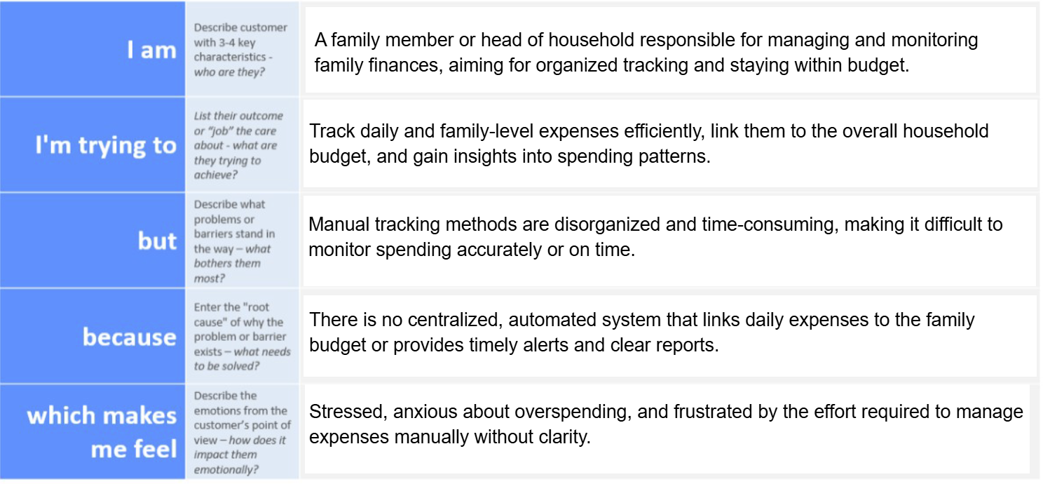

|  |  |  |  |  |  |
| --- | --- | --- | --- | --- | --- |
| **Problem Statement (PS)** | **I am (Customer)** | **I’m trying to** | **But** | **Because** | **Which makes me feel** |
| PS-1 | |  | | --- | |  |  |  | | --- | | Family member /  parent | | Record and track daily expenses | |  | | --- | | I often miss entries |  |  | | --- | |  | | There’s no centralized system | Disorganized and uncertain |
| PS-2 | Family head / budget owner | Stay within a monthly household budget | I don’t get alerts on overspend | |  | | --- | |  |  |  | | --- | | No automated  budget tracking | | Worried and reactive |
| PS-3 | Family member | |  | | --- | |  |  |  | | --- | | Link daily  expenses  to household  spending | | It’s difficult to consolidate | Records are stored separately | Confused and overwhelmed |
| PS-4 | |  | | --- | |  |  |  | | --- | | Financial  planner  (for family) | | Analyze spending patterns | |  | | --- | |  |  |  | | --- | | I lack categorized  reports | | |  | | --- | |  |  |  | | --- | | No reporting  functionality | | Uninformed and unsupported |
| PS-5 | |  | | --- | |  |  |  | | --- | | Tech-savvy  family member | | Manage expense records efficiently | |  | | --- | |  |  |  | | --- | | Data entry is slow  and manual | | No custom forms or automation | Frustrated and inefficient |